A Windows Guide to loading Tachyon Forth into Propeller P1

Introduction
Tachyon Forth is a powerful Forth programming tool set for the Parallax Propeller P1, created by Peter Jakacki. This is a guide by forth enthusiast Bob Edwards about getting Tachyon loaded into the P1 EEPROM, using Windows 10 tools. The method enables the user to alter the kernel if he wishes or choose what modules are loaded to suit the job in hand and to save precious memory.

The Compiler
Tachyon is compiled and loaded using the BST tool currently available here www.fnarfbargle.com/bst.html . Download the latest code for bst, bstc and bstl. Unzip all three and place the programs in a common directory (there is no other installation required ) I made a shortcut to bst on my desktop.

Connecting to the Windows PC
On his Sourceforge web page, Peter Jakacki describes how to compile and flash Tachyon onto the P1 using Linux tools. Something different is needed for Windows users.
- Open Device Manager on the PC and check the Ports (COM & LPT ) available
- Connect the P1 up to a USB port of your PC direct (if onboard USB is present) else via a Parallax Prop Plug. The USB link has to be capable of resetting the P1 processor – the Prop Plug has this reset circuit built-in, so ftdi modules off ebay won’t do, unless modified. Make sure your board is powered up. Be careful that any power provided by the USB link does not conflict with any external power supply to the P1 board.
- In Device Manager, an extra port will have been created – in my case it’s USB-SERIAL CH340 (COM5). Remember the com port number.
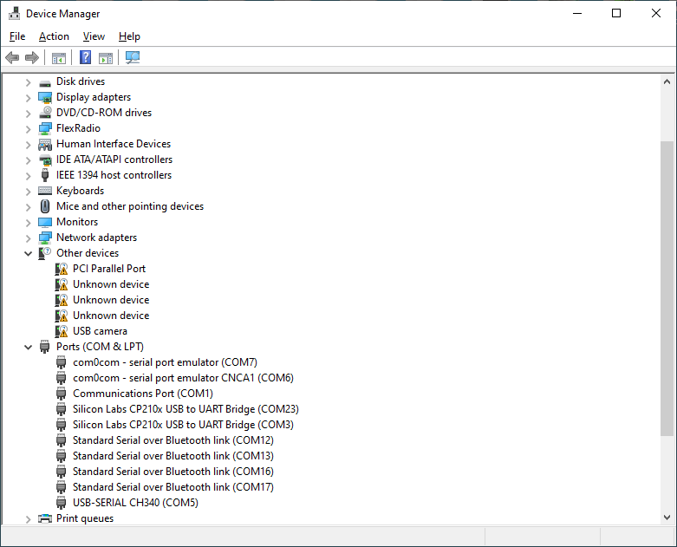

Tachyon Source Code
The Tachyon source code is available at Tachyon Forth - Browse /Tachyon at SourceForge.net.
- From the kernel directory, download tachyon5v7.spin – the source code of the forth kernel.
- From the Forth directory, download Extend.fth ( Extensions to the kernel) and optionally, Easyfile.fth (An SD-card file system ).
The first step is some minor alterations to the source code to define the clock rates on your P1 circuit board:-
- Open BST and load tachyon5v7.spin
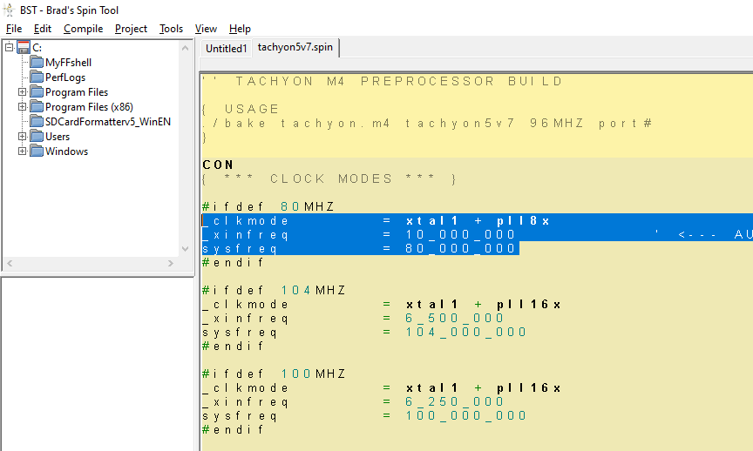
At the start of the code, there are multiple #ifdef - #endif statements that set values into _clkmode, _xinfreq and sysfreq. Delete all these, apart from the ‘80MHz’ code highlighted. You should be left with:-
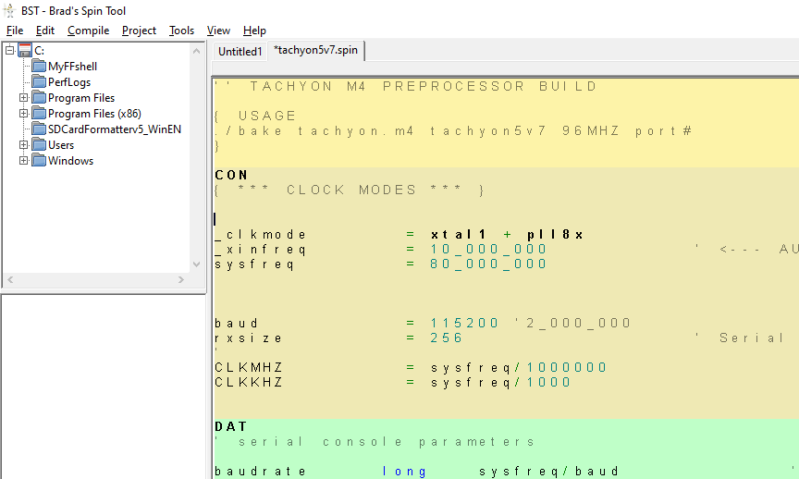
- If your board has a 5 or 10 MHz crystal source for the P1, leave the xinfreq value as 10_000_000. Tachyon will autoadjust on reset. If you have another crystal frequency, then altering the _xinfreq value will be needed.
- Save the source code.
- From the menu bar, select Compile → Compile and Load EEPROM. You may get this popup:-
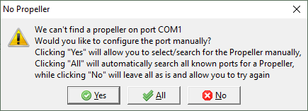
- Press All, the P1 should be autodetected, and the code should be loaded into the EEPROM – progress is shown by this pop-up:-
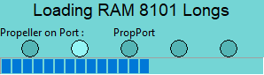
- After this popup disappears, we’re done using the compiler, so close it.

Setting up the terminal link
- Download and install Tera Term from Tera Term Open Source Project (osdn.jp)
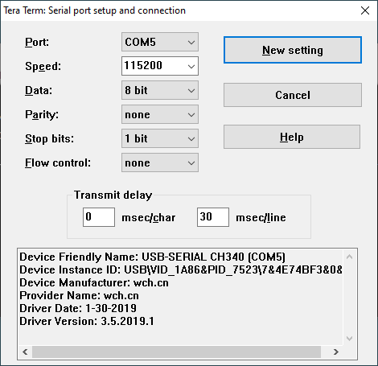
- From the menu bar select Setup → Serial port. Set the Port to the com port that you found using Device Manager. Set Speed to 115200, data to 8 bit, Parity to none, Stop bits 1 bit, Flow Control none and Transmit delay 30 msecs/line. (The latter setting is conservative)

- Press ‘New Setting’ to reset the port to the new values
- Reset the P1 and you should see on the terminal:-
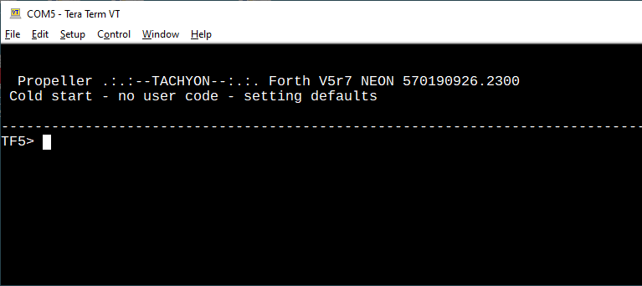
- To check two way comms, type WORDS (must be capitals) and you should get:-
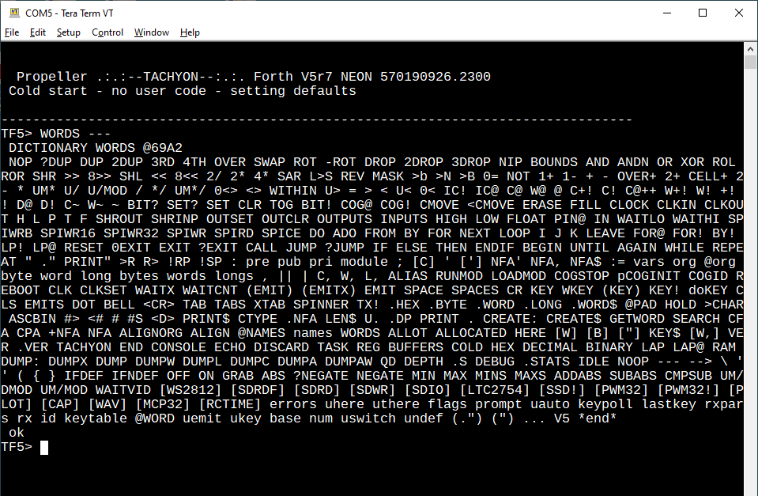
- You’re in business with a very basic Tachyon system

Extending the system
Download Notepad++ from Notepad++ (notepad-plus-plus.org) - it’s a good multi-tab, syntax highlighting editor for wrangling forth source code. Load Extend.fth into it. You may like to make your own Extend.fth by cutting out sections that you’re not interested in, but for now select all of the text with <ctrl> A, copy it to the clipboard with <ctrl> C and right click on Tera Term:-
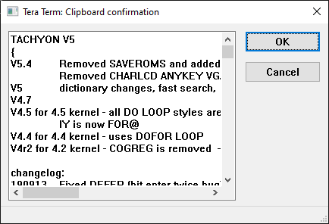
Press OK and the code will start loading into Tachyon with a series of counts displayed. ( You’ll be doing a lot of this when developing your own code ) You’ll eventually see:-
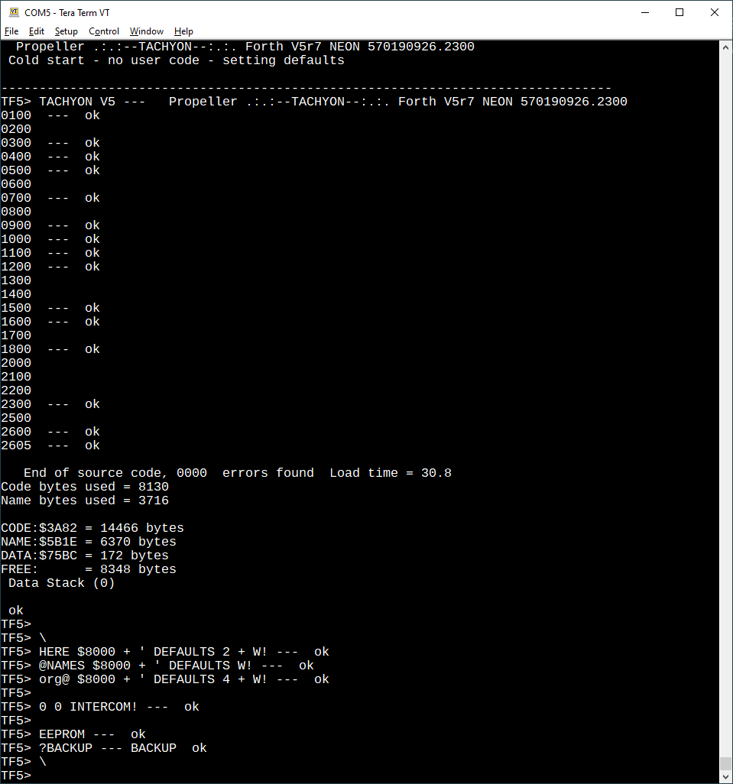
Extend.fth automatically saves the whole forth image to Flash using the ?BACKUP word. This word will not save to EEPROM if any compile error occurred, so watch out for that.
When the P1 is reset, the sign-on message will have changed to:-
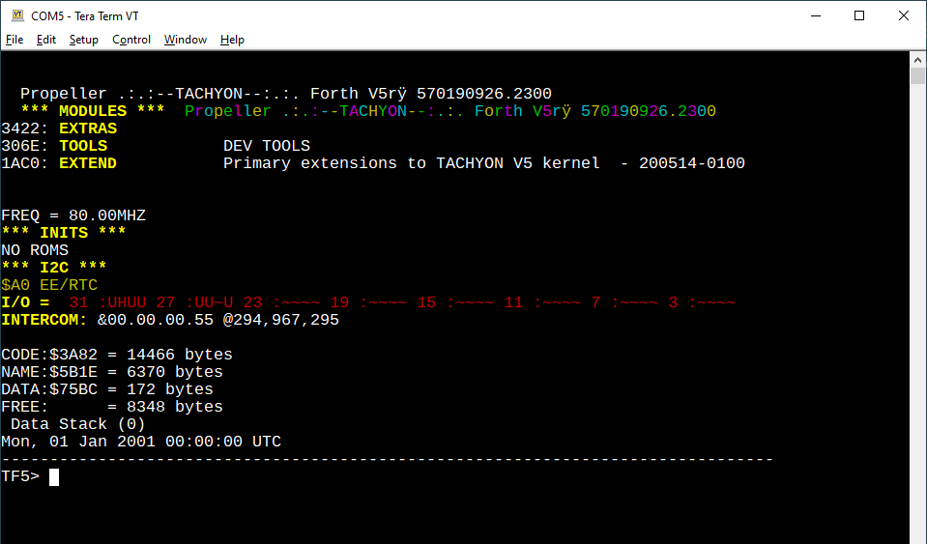
OK – that’s all there is to that. Notice there is 8348 bytes free for your application – which doesn’t sound much. However, providing your application doesn’t have a need for a lot of data space, that’s enough space for a large forth program - you’ll be surprised. More space can be regained, but you lose all the features of EXTEND.fth. Execute COLD and Tachyon restarts with just the kernel in the dictionary and a lot more free space – 20194 bytes for your program:-
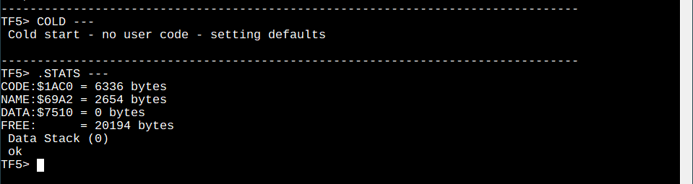
Next time the P1 is reset, Tachyon will restart with all the Extend.fth words present again. The effects of executing COLD are only temporary.

SD Card Support
If you fit an SD card, Sandisk cards are known to work, don’t expect much from unmarked cards you found in your bits box. Format the card with SD card formatter from the SD Association to be sure that Tachyon can understand it, else some formats from other sources don’t work. Load Easyfile.fth to provide the SD card driver – this time you’ll have to manually BACKUP the system to keep the extra code after reset. Be warned, this reduces space for your program to a low level.

Conclusion
This has been guidance on installing Tachyon forth onto the Parallax P1 using Windows tools and loading some forth source code from file Extend.fth. This document was written by Bob Edwards, retired EMC engineer and ham radio operator G4BBY in SW U.K. in September 2022. Hope it’s been helpful and it gets you going with Tachyon!!

